**TSUUP APPLICATION: SIMPLIFYING ACCESS TO EGUSI SOUP RECIPES**

By

**AFOLAYAN OLUWATIMILEHIN ISRAEL**

**Email:** [**afolayantimi555@gmail.com**](mailto:afolayantimi555@gmail.com)

**SID: 080-452**

FACULTY OF SCIENCE AND TECHNOLOGY

A Project Report submitted to the Faculty of Science and Technology in Fulfilments of the Requirements for the Award of the Degree of Bachelor of Software Engineering of Cavendish University Uganda.

**Supervisor**

Edison Kagona

Faculty of Science and Technology, Cavendish University Uganda

[Edisonmat15@gmail.com](mailto:Edisonmat15@gmail.com), +256(0)700814680

June 2024

**DECLARATION**

I, **AFOLAYAN OLUWATIMILEHIN ISRAEL** do declare to the best of my knowledge, efforts and with honesty that the work presented in this practicum report is my original and genuine information gathered during my research and study. It is therefore not a duplicate of any body’s work and has never been presented to any university or institution of higher learning for any award of degree, diploma and certificate or any other academic qualification.

**Signature …………………………… Date………………………………**

**AFOLAYAN OLUWATIMILEHIN ISRAEL**

**STUDENT NO: 080-452**

## **APPROVAL**

This is to certify that the project work titled “Tsuup: Simplifying Access to Egusi Soup Recipes” was prepared and submitted by **AFOLAYAN OLUWATIMILEHIN ISRAEL** to the Faculty of Science and Technology and is accepted by the undersigned, meeting the requirements of the award of the bachelor’s degree (BSE) in Software Engineering at Cavendish University Uganda.

**Signature …………………………… Date………………………………**

**Edison Kagona**

**University Supervisor**

**DEDICATION**

Firstly, I am dedicating this report to the Almighty God.

Secondly, I am dedicating this report to my Parents and my aunt for their love and care in my academic advancement during my study. Their sacrifices and guidance have shaped me into the person I am today and have inspired me to pursue my dreams. I am grateful for their constant belief in me and for instilling in me the importance of hard work and perseverance. This thesis is a testament to their unwavering love and support, and I dedicate it to them with all my heart.

## **ACKNOWLEDGEMENT**

I would like to express my sincere gratitude to my family, who have been my unwavering source of love, support, and encouragement throughout my academic journey. Their sacrifices and encouragement have helped me to overcome the challenges and hurdles that I have encountered along the way, and I am truly grateful for their constant belief in me.

I would also like to thank my project supervisor, Edison Kagona, for his invaluable guidance, support, and feedback throughout the course of this project. His dedication and expertise have been instrumental in shaping the direction and focus of this research, and I am truly grateful for his assistance.

Lastly, I would like to acknowledge the grace of God, who has been my ultimate source of strength and inspiration. Without His guidance and blessings, this project would not have been possible. I am grateful for His unwavering love and faithfulness, and for the countless blessings that He has bestowed upon me throughout my life.

**Contents**

DECLARATION 2

APPROVAL 2

DEDICATION 3

ACKNOWLEDGEMENT 4

1.0 Introduction 6

1.1 Background 6

1.2 Problem Statement 8

1.3 Objectives 8

1.3.1 Main Objectives 8

1.3.2 Specific Objectives 8

1.4 Research Scope 8

1.5 Significance of the Research 9

2.0 LITERATURE REVIEW 10

2.1 Introduction 10

2.3 Cultural Significance of Nigerian Cuisine 11

2.4 Challenges in Cooking Traditional Nigerian Soups 11

2.5 Technological Innovations in Culinary Applications 12

2.6 Contributions and Gaps 13

3.0 METHODOLOGY 15

3.1 Introduction 15

3.2 System Study Tools and Technique 15

3.3 System Analysis and design 16

3.4 System Implementation 17

3.5 System testing and validation 18

4.0 SYSTEM STUDY, ANALYSIS AND DESIGN 19

4.1 Introduction 20

4.2 System study 20

4.3 System design 20

4.3.1 System Architecture design of the system 20

4.3.2 Process modeling 21

4.4 System analysis 22

4.4.3 Non-Functional Requirement 23

5.0 SYSTEM IMPLEMENTATION, TESTING AND VALIDATION RESULTS 24

5.1 INTRODUCTION 24

5.2 FUNCTIONS PROVIDED BY THE APPLICATION 24

5.3 SAMPLE SCREENSHOTS 24

5.4 SYSTEM TESTING AND VALIDATION RESULT 32

5.4.1 Testing Process: 33

5.4.2 Validation Results: 33

5.4.3 Suggestion for improvement 33

5.5 SYSTEM REQUIREMENTS 33

5.5.1 Hardware Requirements: 33

5.5.2 Software Requirements: 34

6.0 CONCLUSION AND FUTURE WORK 35

6.1 Conclusion: 35

6.2 Future work 35

6.3 References 36

6.4 Appendices 37

**CHAPTER ONE**

# **Introduction**

This chapter discusses the background to the study, problem statement, objectives, scope and significance of the Tsuup application.

# **Background**

The Nigerian community is growing in different parts of the world, from Europe to the Americas, Asia, and Australia, and as their population grows in the diaspora, they long for their spicy soups from Nigeria, from the hearty Egusi and Ogbono recipes to the spicy Pepper Soup, Afang, and many more recipes. For several years now, Nigerian recipes have been finding their way through the bellies of aircraft to different international destinations (Eze, 2022).

Globally, Soup is a universal dish that can be enjoyed in any season, any time of the day, and any place in the world. It is a versatile and nourishing meal that can be made with various ingredients, flavors, and textures (Fauzanbisyir, 2023). Nigerian cuisine is renowned for its rich and diverse flavors, with soups playing a central role in the country's culinary tradition, and their soups are beloved for their depth of flavor and cultural significance. With Egusi being the most popular soup in Nigeria, it is a well-known Yoruba dish made from ground melon seeds. It is commonly enjoyed in countries such as Nigeria, Ghana, and Cameroon and it has managed to gain popularity not just in Nigeria but in Africa and other continents like Europe, Asia, and the United States.Egusi is indigenous to West and Central Africa. It thrives in dry, tropical, and subtropical climates with light, sandy soils that drain water well. It is cultivated in home gardens and small farms throughout West Africa not only for personal consumption but as a valuable cash crop due to its economic and nutritional benefits. This gourd can be found in a variety of settings including cultivated lands, disturbed sites, landfills, shores, and areas around sewage plants. Egusi was introduced to Mediterranean Africa, the Middle East, and West Asia before 1000 BC, reached China around 900 AD, and Japan in the 1500s. Brought to Brazil by Africans in the 1700s and later introduced to the United States after colonization, it is now found in most states as well as Puerto Rico and the Virgin Islands. Egusi's ease of cultivation, pest resistance, soil-improving qualities, and ability to grow in barren areas have made it a viable food source globally, particularly in regions with less-than-ideal farming conditions. While readily available in West African markets, Egusi seeds can also be found in farmer’s markets and West African grocery stores in countries like Germany, England, and the United States (Specialty Produce, n.d.).

Egusi is indigenous to West and Central Africa. It thrives in dry, tropical, and subtropical climates with light, sandy soils that drain water well. It is cultivated in home gardens and small farms throughout West Africa not only for personal consumption but as a valuable cash crop due to its economic and nutritional benefits. This gourd can be found in a variety of settings including cultivated lands, disturbed sites, landfills, shores, and areas around sewage plants. Egusi was introduced to Mediterranean Africa, the Middle East, and West Asia before 1000 BC, reached China around 900 AD, and Japan in the 1500s. Brought to Brazil by Africans in the 1700s and later introduced to the United States after colonization, it is now found in most states as well as Puerto Rico and the Virgin Islands. Egusi's ease of cultivation, pest resistance, soil-improving qualities, and ability to grow in barren areas have made it a viable food source globally, particularly in regions with less-than-ideal farming conditions. While readily available in West African markets, Egusi seeds can also be found in farmer’s markets and West African grocery stores in countries like Germany, England, and the United States (Specialty Produce, n.d.).

Egusi gained its popularity to many countries all over the world because of its rich flavor and thick, hearty consistency. Egusi seeds are very high in oil. They’re 50% oil, 78% of which is unsaturated fatty acids, which are the healthier type of fat! The oil produced from these seeds is rich and flavorful. They’re also 35% protein. Egusi seeds are rich in vitamin A, which is crucial for forming and maintaining healthy bones. In addition, Egusi seeds are high in vitamins B1 and B2, which are both important for growth and the production of red blood cells. There’s a high concentration of vitamin C, too, which helps the body absorb iron and maintain healthy tissue. Finally, Egusi seeds are also high in Niacin, which helps maintain healthy skin (Egunsi Soup, 2021).

However, for many, the process of preparing these soups can be daunting due to the complexity of recipes and the difficulty in sourcing authentic ingredients.

## **Problem Statement**

The culinary tradition of Nigerian soups is rich and diverse, offering a wide array of flavors and nutritional benefits. However, some challenges hinder many individuals, both within Nigeria and Outside Nigeria, especially those from Generation Z and young adults, they face a decline in cooking skills, intensified by the complexity of Nigerian soup recipes and difficulty in providing authentic and healthy ingredients. This trend threatens Nigerian culinary heritage and promotes poor diet habits within and outside Nigeria.

This is where Tsuup Application comes in, Tsuup aims to address this by providing an easy-to-use app with simplified Egusi recipes, ingredient sourcing solutions, and educational resources to help users cook and enjoy Egusi.

## **Objectives**

### **Main Objectives**

The main objective of the Tsuup project is to promote and preserve Nigerian culinary heritage by making traditional soup recipes accessible and manageable for users both within Nigeria and outside Nigeria, also targeting Generation Z and young adults who may lack cooking skills or access to authentic ingredients.

### **Specific Objectives**

* 1. To study existing recipe applications and identify the requirements for a comprehensive Egusi recipe and ordering mobile application.
  2. To design a user-friendly mobile application that provides detailed Egusi recipes, step-by-step preparation guides, and an integrated ordering system for users to purchase Egusi ingredients.
  3. To implement, test, and validate the designed Tsuup application, ensuring it meets user needs and provides a seamless experience for both recipe guidance and ingredient ordering.

## **Research Scope**

The Tsuup application is developed to provide users with a comprehensive solution for accessing Egusi recipes and ordering ingredients. This application targets individuals interested in preparing Egusi dishes and those seeking a convenient way to obtain the necessary ingredients. The scope of this research covers the design and implementation of the Tsuup mobile application, with functionalities restricted to the following:

1. **Recipe Information:** Providing detailed ingredients for preparing Egusi Soup.
2. **Preparation Steps**: Providing step-by-step preparation guides for the Egusi recipe.
3. **Ordering System:** Enabling users to order Egusi recipe directly through the application, it redirects you to a website where users can order from.

## **Significance of the Research**

Tsuup project holds significant academic and practical relevance by preserving and promoting Nigerian culinary heritage through accessible, authentic recipes. It bridges traditional cooking techniques with modern convenience, enriching culinary knowledge globally. This technological advancement enhances culinary education and accessibility, fostering socio-economic development by supporting local food ecosystems and cultural awareness.

Tsuup's focus on soups and its integrated features:

**User Empowerment:** The application provides users with detailed and easy-to-follow Egusi recipes, enabling them to prepare traditional dishes confidently and accurately.

**Convenient Ingredient Procurement:** By offering an integrated ordering system, users can conveniently purchase Egusi ingredients directly through the app, saving time and effort.

**Culinary Education:** The step-by-step preparation guides serve as an educational tool for individuals looking to expand their cooking skills, particularly in preparing Egusi dishes.

**Reference for Future Research:** This project serves as a valuable reference for other researchers interested in developing similar culinary applications, contributing to the broader knowledge base in the field of mobile application development for culinary purposes.

Its continued relevance lies in its ability to meet evolving culinary interests while offering a platform for both learning and community engagement in culinary traditions.

**CHAPTER TWO**

## **LITERATURE REVIEW**

## **Introduction**

The literature review explores existing research and projects related to Nigerian cuisine, focusing on soups, to identify contributions, weaknesses, and gaps that inform the development of Tsuup. This section aims to support the project’s objectives, meaning and purpose of Tsuup application, Cultural Significance of Nigerian Cuisine, Challenges in cooking Nigerian Soup, Technological Innovations in Culinary Applications, Contributions and Gaps.

* 1. **Meaning and Purpose of Tsuup Application**

Tsuup stands as an acronym for "**Timilehin Soup Ordering and Understanding Platform**”. The Tsuup App is a specialized mobile application designed exclusively for enthusiasts and connoisseurs of Egusi soup. Its primary objective is to serve as a comprehensive digital resource dedicated to this traditional African dish, offering users detailed information on ingredients, preparation steps, and convenient access to external sources for ordering the soup itself.

**Purpose:** The purpose of the Tsuup App is multifaceted:

* 1. **Ingredient Information:** It provides users with a detailed list of ingredients required to prepare Egusi soup, ensuring accuracy and authenticity in their culinary endeavors.
  2. **Preparation Steps:** Users can access step-by-step instructions for preparing Egusi soup, including variations and tips for enhancing flavor and texture.
  3. **Ordering Convenience:** The app facilitates user convenience by offering links to external websites where Egusi soup and other Nigerian soups can be purchased online, streamlining the shopping process for users.

Through these features, Tsuup not only serves as a practical guide for preparing Egusi soup but also fosters a sense of community and cultural appreciation among its users. By leveraging digital technology, Tsuup enhances accessibility to this traditional dish, catering to both seasoned cooks and curious newcomers eager to explore African cuisine.

Overall, Tsuup embodies a blend of culinary heritage and technological innovation, aiming to enrich the culinary experiences of its users while promoting the cultural significance of Egusi soup in a digital age.

## **Cultural Significance of Nigerian Cuisine**

Nigerian cuisine holds profound cultural significance both within its regional contexts and on a global scale. Rooted in diverse ethnic traditions and influenced by centuries of trade and migration, Nigerian cuisine represents a rich tapestry of flavors, ingredients, and culinary techniques.

1. **Diversity and Regional Variations:** Nigerian cuisine is characterized by its diversity, with each ethnic group contributing unique dishes and cooking styles. From the savory stews of the Yoruba in the west to the spicy soups of the Igbo in the east and the hearty meals of the Hausa-Fulani in the north, Nigerian cuisine reflects the country's cultural diversity and geographical landscapes.
2. **Role in Identity Formation:** Nigerian dishes, including soups like Egusi, Ogbono, and Bitter-leaf soup, play a pivotal role in identity formation and cultural expression. These dishes are often associated with familial traditions, communal gatherings, and festive celebrations, serving as markers of cultural pride and heritage.
3. **Culinary Traditions and Rituals:** Culinary traditions in Nigeria are deeply intertwined with social rituals and customs. Cooking and sharing meals are integral to community bonding and hospitality practices, where generous portions and communal dining foster a sense of unity and belonging.
4. **Global Influence and Adaptation:** Nigerian cuisine has gained international recognition and influence, owing to the Nigerian diaspora and the global popularity of dishes like Jollof rice, Suya, and Pounded Yam. Nigerian restaurants and food festivals worldwide celebrate the country's culinary prowess and contribute to global gastronomic diversity.
5. **Research Insights:** (Smith, 2018) emphasize the cultural importance of Nigerian soups in regional and global contexts, highlighting their role in culinary traditions and identity formation.

## **Challenges in Cooking Traditional Nigerian Soups**

Cooking traditional Nigerian soups, such as Egusi soup, presents a range of challenges that impact both novice cooks and experienced chefs alike. These challenges stem from the complexity of recipes, sourcing authentic ingredients, and the need for educational resources to ensure culinary authenticity and success.

1. **Complexity of Recipes:** Traditional Nigerian soups often feature intricate recipes that require precise measurements, multiple cooking techniques, and specific ingredient combinations. The complexity can be daunting for individuals unfamiliar with Nigerian cuisine, leading to uncertainty and potential errors in preparation.
2. **Difficulty Sourcing Authentic Ingredients:** Authenticity in Nigerian cooking heavily relies on sourcing traditional ingredients that may not be readily available in all regions or countries. Staples like Egusi (melon seeds), Ogbono (African bush mango seeds), and authentic spices are essential for flavor and texture but can pose challenges in procurement outside of Nigeria.
3. **Cultural and Educational Resources:** Lack of cultural and educational resources exacerbates the difficulty in mastering traditional Nigerian soups. Understanding the cultural context, regional variations, and cooking techniques requires accessible and accurate information, which may be limited in mainstream culinary resource
4. **Research Insights:** (Adams, 2019) highlights these challenges, emphasizing the complexities of recipes and the difficulty in sourcing authentic ingredients. The study underscores the necessity for educational resources and practical solutions, as proposed by innovative platforms like Tsuup. Tsuup addresses these challenges by providing comprehensive guides, ingredient lists, and links to reputable suppliers, thereby enhancing accessibility and authenticity in preparing Nigerian soups.

## **Technological Innovations in Culinary Applications**

Advancements in technology have revolutionized culinary applications, enhancing culinary education, recipe sharing, and user engagement across diverse platforms. Recent literature (Lee and Kim, 2022) (Roberts, 2017) explores these innovations, offering valuable insights into effective features and strategies applicable to modern culinary apps like Tsuup.

1. **Mobile Applications for Culinary Education:** Mobile apps have democratized culinary education by providing accessible, interactive platforms for learning. They offer features such as step-by-step recipe guides, instructional videos, and cooking tips tailored to users' skill levels and preferences. This approach not only enhances learning efficiency but also encourages experimentation and creativity in the kitchen.
2. **Recipe Sharing and Community Engagement:** Culinary apps facilitate extensive recipe sharing among users, fostering a vibrant community of food enthusiasts. Features like user-generated content, ratings, and reviews promote culinary diversity and cultural exchange. Social sharing functionalities enable users to showcase their creations, receive feedback, and connect with like-minded individuals globally.
3. **Integration of AI and Machine Learning:** AI-powered recommendations and personalized cooking suggestions are emerging trends in culinary apps. These technologies analyze user preferences, dietary restrictions, and ingredient availability to suggest relevant recipes and cooking techniques. Machine learning algorithms continuously improve recommendations based on user interactions, enhancing user satisfaction and engagement.
4. **Research Insights:** Literature (Lee and Kim, 2022) (Roberts, 2017)discusses advancements in mobile applications for culinary education and recipe sharing, providing insights into effective features and user engagement strategies applicable to Tsuup.

## **Contributions and Gaps**

The existing literature highlights the cultural and socio-economic importance of preserving Nigerian culinary traditions, emphasizing their role in identity formation and cultural exchange. However, gaps persist in accessible, user-centric platforms that specifically focus on traditional Nigerian soups.

1. **Cultural and Socio-Economic Significance:** Research underscores the profound cultural significance of Nigerian culinary traditions, including soups like Egusi and Ogbono, in shaping cultural identity and fostering community cohesion. These dishes not only reflect regional diversity but also contribute to culinary heritage preservation and cultural pride.
2. **Gaps in Existing Platforms:** Despite recognition of their significance, there remains a noticeable gap in platforms that cater to the specific needs of individuals interested in preparing traditional Nigerian soups. Existing resources often lack comprehensive recipes, reliable ingredient sourcing solutions, and community engagement features tailored to contemporary culinary enthusiasts.
3. **Tsuup's Contribution:** Tsuup aims to address these gaps by providing a dedicated platform focused on traditional Nigerian soups, such as Egusi soup. It integrates:
   * **Comprehensive Recipes:** Detailed guides and step-by-step instructions for preparing authentic Nigerian soups.
   * **Ingredient Sourcing Solutions:** Links to reputable suppliers for sourcing authentic ingredients, ensuring culinary authenticity.
   * **Community Engagement:** Features for user interaction, recipe sharing, and cultural exchange, fostering a vibrant community of food enthusiasts.
4. **Future Directions:** Moving forward, there is a need for continued innovation and expansion in platforms like Tsuup to encompass a wider range of Nigerian dishes and accommodate diverse user preferences and dietary needs. Enhancing accessibility, inclusivity, and sustainability in culinary education and cultural preservation efforts will further strengthen the platform's impact and relevance.

**CHAPTER THREE**

## **METHODOLOGY**

## **Introduction**

This chapter explores the study tools and technique, system analysis and design, system implementation, system testing and Validation.

## **System Study Tools and Technique**

In this study, the following tools and techniques were used to collect data and study the Tsuup application:

* 1. **Online Search:** an online search was conducted using various search engines like Google to gather information on the existing recipes and cooking methods for egusi soup. This search was done to gather background information on the topic and to identify gaps in existing literature.
  2. **Observational Study:** I observed the user interface of the Tsuup application to understand how users interact with the app and identify any potential issues or areas for improvement. The observational study was done by using the app on a smartphone and taking notes on the user experience.
  3. **Surveys:** A survey was conducted among users of the Tsuup application to gather feedback on their experience with the app.
  4. **Focus Group Discussion:** ocuus group discussion was conducted with a group of 10 users who have used the Tsuup application to gather more in-depth feedback on their experience with the app. The discussion was moderated by me and focused on users' experiences with preparing egusi soup using the app, as well as their suggestions for improving the app.
  5. **Interviews:** In-depth interviews were conducted with 5 experts in the field of cooking and nutrition to gather more in-depth information on the nutritional benefits of egusi soup and its preparation methods. The interviews were recorded using a digital recorder and transcribed verbatim.
  6. **Website Review:** A review of the external website provided by Tsuup was conducted to gather information on how users can order the egusi soup and other Nigerian Soups.
  7. **Data Collection Tools**

The following data collection tools were used in this study:

* Survey questionnaire (Appendix A)
* Focus group discussion guide (Appendix B)
* Interview protocol (Appendix C)

Note: Appendices A, B, and C will be included in the appendix section of this report.

## **System Analysis and design**

The System Analysis and Design phase involved using various tools and techniques to analyze the system requirements and design the Tsuup app.

**System Analysis**

For system analysis, we used the following tools and techniques:

1. **Data Analysis**: We used Microsoft Excel to analyze the data collected through online search, surveys, expert interviews, and focus group discussion. We applied descriptive statistics to identify patterns, trends, and correlations in the data.
2. **Requirement Elicitation**: We used a combination of techniques, including brainstorming sessions, mind mapping, and flowcharts to identify the system requirements for the Tsuup app. This involved identifying the key components of the app, including the list of ingredients, recipe preparation methods, and external website for ordering recipes.
3. **Use Cases**: We used use cases to identify the user interactions with the Tsuup app, including the user's goals, tasks, and behaviors. This helped to define the functional requirements of the app.

**System Design**

For system design, we used the following tools and techniques:

1. **Process Modeling**: We used flowcharts to model the flow of information and sequence of events as they occur in the Tsuup app. This helped to visualize the system's behavior and identify potential issues or bottlenecks.
2. **Use Case Diagrams**: We used use case diagrams to visualize the user interactions with the app and identify the relationships between different actors and use cases.
3. **Wireframes**: We used wireframes to create low-fidelity prototypes of the app's user interface and user experience. This helped to visualize the app's layout and functionality.

**Tools Used**

The following tools were used for system analysis and design:

* Microsoft Excel (for data analysis)
* Flowcharts (for process modeling)
* Use Case diagrams (for use case modeling)
* Wireframes (for user interface design)

By using these tools and techniques, we were able to analyze the system requirements and design a functional and user-friendly app that meets the needs of users.

## **System Implementation**

The System Implementation phase involved translating the design into a functional and user-friendly app. The following tools and technologies were used to implement the design:

**Front-end Development**

For the front-end development of the Tsuup app, I used Android Studio, which is an Integrated Development Environment (IDE) specifically designed for Android app development. Android Studio provided us with the necessary tools and features to design, develop, and test the app's user interface and user experience.

**Implementation Plan**

The implementation plan involved the following steps:

1. Designing the user interface and user experience using Android Studio
2. Developing the app's functionality using Java programming language
3. Integrating the database management system (SQLite) with the app
4. Testing and debugging the app to ensure that it meets the requirements and is free of errors
5. The following are various tools and software that were used in the development of the system:

Below are the tools and programming language I used to develop Tsuup App:

**Android Studio** helped us to design and develop the app's user interface and user experience, which is critical for an app's success.

1. **JAVA**

Java is a general-purpose, open-source, platform-agnostic programming language released in 1995 by Sun Microsystems. Currently, the company’s owner is Oracle. Java is also a platform comprising a set of libraries and tools for efficient Java app development1.

Java has long been one of the most popular programming languages used in Android app development.

According to researchers, Java is the most popular language for cloud app development. One of the main reasons is the wide choice of libraries, which allows developers to implement new functions and build micro-services. Another advantage is adaptability.

Java has been used in developing various applications such as desktop apps, web apps, mobile apps, games and much more3. It has been used to develop Android apps since its inception.

Java has been used as a primary programming language in developing many popular applications such as Mine-craft, Apache Hadoop, Apache Tomcat, and many more.

1. **Glide**

Glide is an open-source media management and image loading framework for Android that wraps media decoding, memory and disk caching, and resource pooling into a simple and easy-to-use interface. Glide is used to load images from the internet or local storage into an ImageView. Glide is a fast and efficient image loading library for Android focused on smooth scrolling.

The Glide dependency was used to load all the soup images in the app.

1. **LifeCycle Dependency**

The lifecycle dependency is a part of Android Jetpack. It provides a way to perform an action when a lifecycle owner (like an activity or fragment) reaches a certain state in its lifecycle. The lifecycle dependency is used to manage the lifecycle of components like activities and fragments. It provides a way to perform an action when a lifecycle owner (like an activity or fragment) reaches a certain state in its lifecycle. For example, you can use the lifecycle dependency to automatically start and stop a media player when an activity is started and stopped.

This software allows for a more robust and well structure application, increasing the speed and efficiency and overall user experience of the application.

## **System testing and validation**

The System Testing and Validation phase involved testing and validating the Tsuup app to ensure that it meets the requirements and is free of errors. The following techniques were used to test and validate the system:

**Testing Techniques**

1. **Unit Testing**: I used unit testing to verify that individual components of the app, such as the user interface, business logic, and data storage, function as expected. I wrote unit tests using the JUnit testing framework to test each component in isolation.
2. **Integration Testing**: I used integration testing to verify that different components of the app work together seamlessly. I tested the app's functionality by simulating user interactions, such as searching for recipes, adding ingredients to a list, and viewing recipe details.
3. **System Testing**: I used system testing to verify that the app's overall functionality meets the requirements. I tested the app's performance, scalability, and security by simulating a large number of users and testing the app's response times.

**Validation Techniques**

1. **Equivalence Partitioning**: I used equivalence partitioning to divide the input data into partitions based on their characteristics, such as valid and invalid user input. I tested each partition to ensure that the app handles each type of input correctly.
2. **Boundary Value Analysis**: I used boundary value analysis to identify the boundaries of input data, such as minimum and maximum values, and tested the app's behavior at these boundaries.
3. **State Transition Testing**: I used state transition testing to identify the different states that the app can be in, such as searching for recipes or viewing recipe details, and tested the app's behavior when transitioning between these states.

**Tools Used**

The following tools were used for testing and validation:

* JUnit (for unit testing)
* Android Studio (for integration testing and system testing)

By using these techniques and tools, we were able to test and validate the Tsuup app thoroughly, ensuring that it meets the requirements and is free of errors.

**CHAPTER FOUR**

## **SYSTEM STUDY, ANALYSIS AND DESIGN**

## **Introduction**

This chapter explores the system study, system analysis, system design, architectural design of the system and process modeling.

## **System study**

The purpose of this system study is to examine the current situation of the Tsuup app and its underlying system, identifying the strengths, weaknesses, opportunities, and threats (SWOT analysis) of the existing system. This study will help us understand the present situation and how business is conducted, as well as identify the challenges with the current system.

**Present Situation**

The current system of the Tsuup app is a mobile-based application that allows users to view the ingredients of egusi soup, view the preparation steps, and a website where users can order the recipe. The app is designed to provide users with a convenient way to plan and manage their meals. However, the current system has several limitations that affect its efficiency and effectiveness.

**Challenges with the current system**

The current system of the Tsuup app faces several challenges that affect its efficiency and effectiveness. Some of these challenges include:

1. **Search Functionality**: The current system lacks a robust search functionality, which can make it difficult for users to find recipes that meet their dietary needs.
2. **Data Management**: The current system does not have a robust data management system, which can lead to data inconsistencies and inaccuracies.
3. **User Interface**: The current system has an inadequate user interface that can make it difficult for users to navigate and use the app effectively.
4. **Lack of Integration with Other Systems**: The current system does not integrate with other systems, such as meal planning software or online grocery stores, which can limit its functionality and usability.

## **System design**

The system design for the Tsuup application is divided into two main parts: process modeling and data modeling. Additionally, the architectural design of the system is provided to illustrate how the system components are interconnected and organized.

## **System Architecture design of the system**

The architectural design of the Tsuup application involves a three-tier architecture, consisting of the presentation layer, business logic layer, and data access layer. This structure ensures the separation of concerns, facilitating maintainability and scalability.

Diagrammatic Representation of the System Architecture:

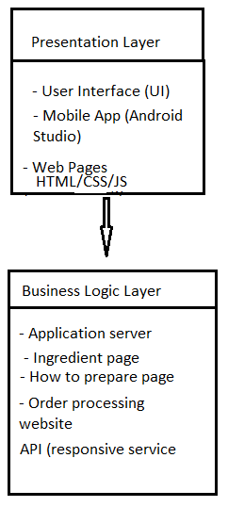

## **Process modeling**

For processing modeling, the object-oriented analysis and design(OOAD) approach is employed using use case and sequence diagrams to demonstrate the flow of information and sequence of events within the system.

Below is a diagram for process modeling:

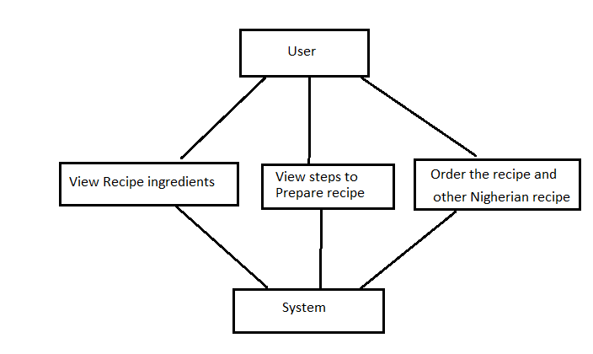

## **System analysis**

System analysis involves specifying the proposed system based on the results of the system study. In this section, we present the requirements for the Tsuup application.

#### **User Requirements**

The user requirements focus on what users need from the Tsuup application. These requirements are derived from user interactions, feedback, and expectations.

1. **User-Friendly Interface**: The application must have an intuitive and easy-to-navigate interface suitable for all users, including those with minimal technical skills.
2. **Ingredient List Accessibility**: Users should be able to easily access and view the complete list of ingredients required to prepare egusi soup.
3. **Step-by-Step Preparation Guide**: The app should provide a detailed, easy-to-follow guide on how to prepare egusi soup.
4. **Recipe Ordering Option**: Users should have the option to order the recipe directly through an integrated external website.
5. **User Account Management**: The application should allow users to create and manage their accounts to save their preferences and order history.
6. **Search Functionality**: Users should be able to search for specific ingredients or preparation steps within the app.
7. **Feedback Mechanism**: There should be an option for users to provide feedback or report issues within the application.

#### **Functional Requirements**

Functional requirements describe the specific behavior and functions of the Tsuup application. These include the features and operations the system must perform.

1. **User-Friendly Interface**: The application must have an intuitive and easy-to-navigate interface suitable for all users, including those with minimal technical skills.
2. **Ingredient List Accessibility**: Users should be able to easily access and view the complete list of ingredients required to prepare egusi soup.
3. **Step-by-Step Preparation Guide**: The app should provide a detailed, easy-to-follow guide on how to prepare egusi soup.
4. **Recipe Ordering Option**: Users should have the option to order the recipe directly through an integrated external website.
5. **User Account Management**: The application should allow users to create and manage their accounts to save their preferences and order history.
6. **Search Functionality**: Users will be allowed to search for other Nigerian recipes in the external website.

# **Non-Functional Requirement**

**Non**-functional requirements define the performance criteria and quality attributes the system must meet:

1. **Performance**: The system must be responsive, with page load times not exceeding three seconds under normal conditions.
2. **Scalability**: The system should be scalable to handle an increasing number of users and database entries without compromising performance.
3. **Security**: The system must ensure data security and user privacy through encryption, secure authentication, and regular security updates.
4. **Usability**: The application should be designed for ease of use, ensuring a positive user experience through a clear and consistent interface.
5. **Reliability**: The system must be reliable, with a target uptime of 99.9% to ensure it is available whenever users need it.
6. **Compatibility**: The application should be compatible with various devices and operating systems, including Android, iOS, and web browsers.
7. **Maintainability**: The system should be designed with maintainability in mind, allowing for easy updates and modifications as needed.

These specifications provide a clear outline of the requirements for the Tsuup application, ensuring it meets the needs and expectations of its users while performing efficiently and reliably.

**CHAPTER FIVE**

## **5.0 SYSTEM IMPLEMENTATION, TESTING AND VALIDATION RESULTS**

## **INTRODUCTION**

This chapter provides a detailed account of the implementation, testing, and validation of the Tsuup application. It covers the functionalities offered by the system, illustrated through sample screenshots, and discusses the results of system testing and validation. Finally, it outlines the minimum hardware and software requirements necessary for the system to function effectively.

## **FUNCTIONS PROVIDED BY THE APPLICATION**

Below are the function the app can do:

1. **View Ingredient List**: Users can view a detailed list of ingredients required for egusi soup.
2. **Access Preparation Guide**: Users can follow a step-by-step guide to prepare egusi soup.
3. **Order Recipes**: Users can order the recipe or ingredients through an integrated external website.
4. **Account Management**: Users can create and manage their accounts, including updating personal information and viewing order history.
5. **Search Functionality**: Users can search for other Nigerian recipes to order on the website.
6. **Feedback Submission**: Users can provide feedback or report issues on the website.

## **SAMPLE SCREENSHOTS**

**How the app runs**

**Open Tsuup –** See splash screen

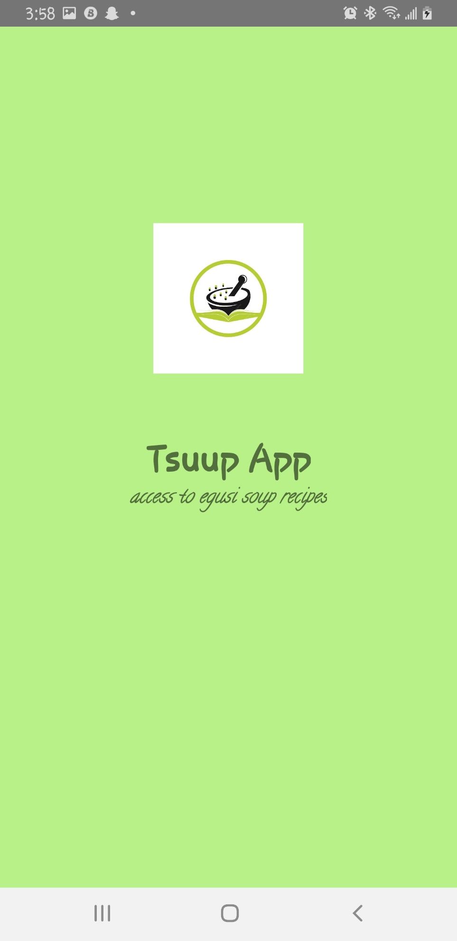

**After 3 seconds of the splash screen –See home page with Egusi button**

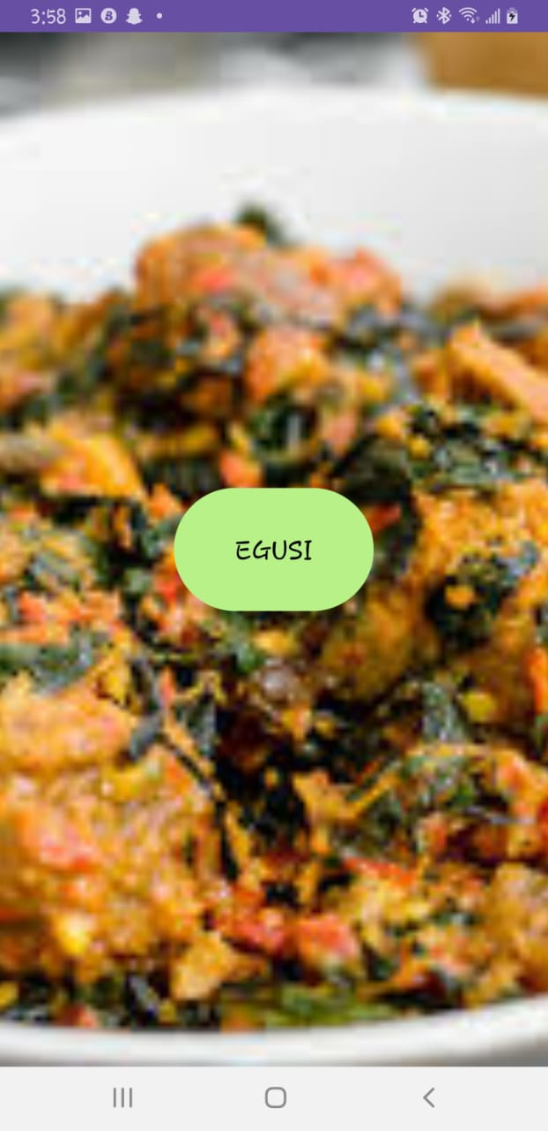

**After clicking egusi button – See the ingredients page**

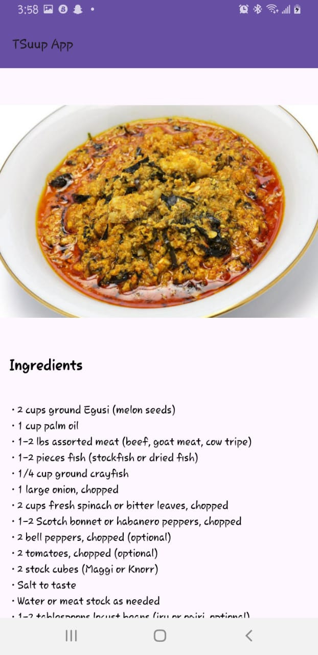

**Swipe down to see the preparation steps button**

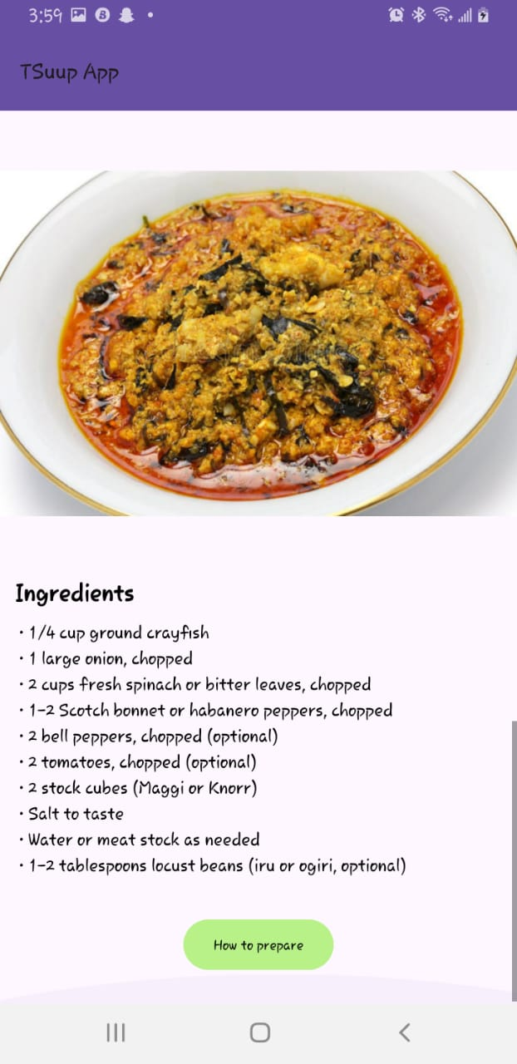

**After clicking on how to prepare – see the preparation steps**

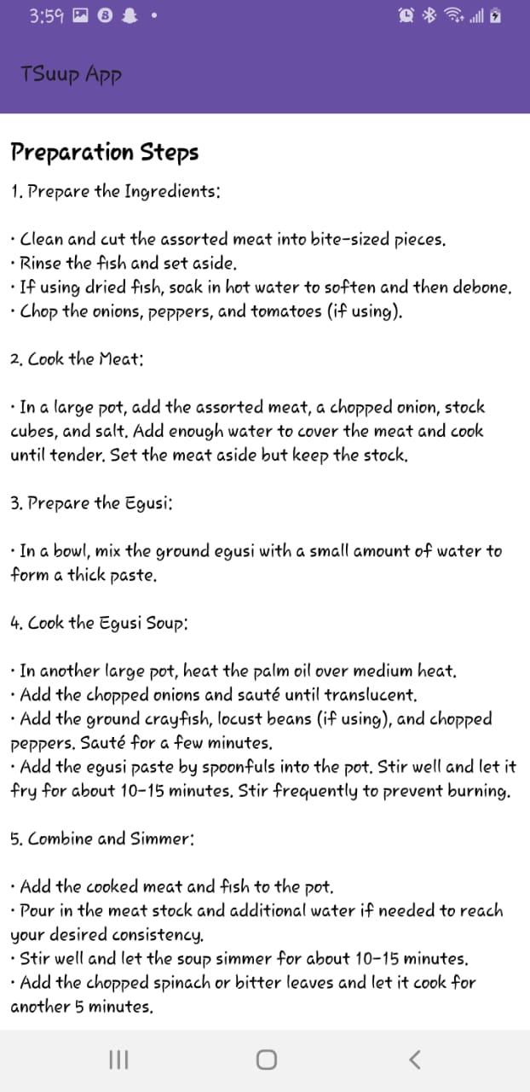

**Swipe down to see the button that takes you to where to order the recipe**

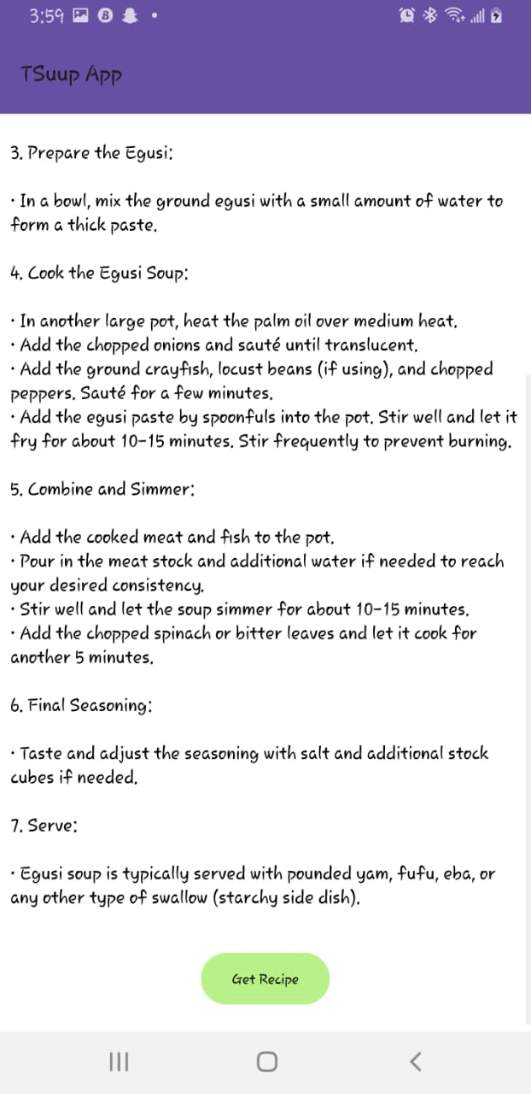

**After clicking on get recipe – it takes you to an external website where you can get Egusi recipe**

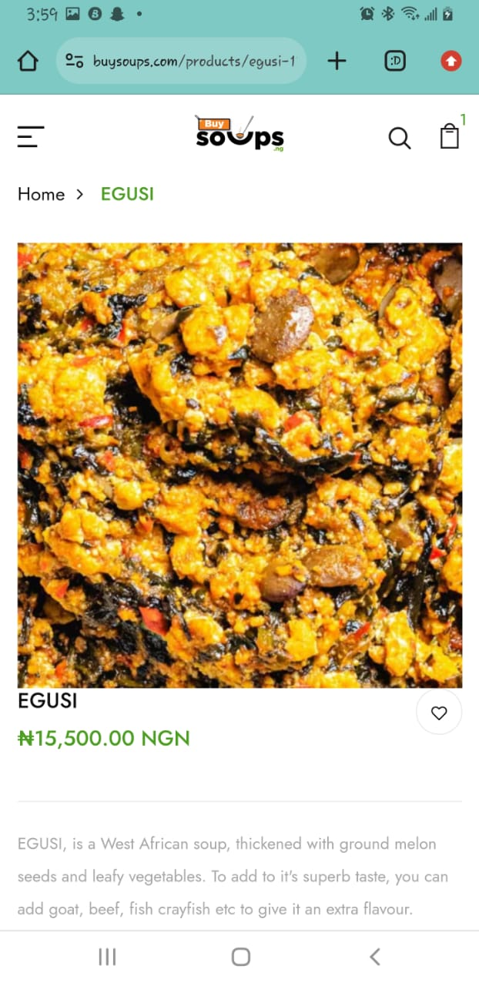

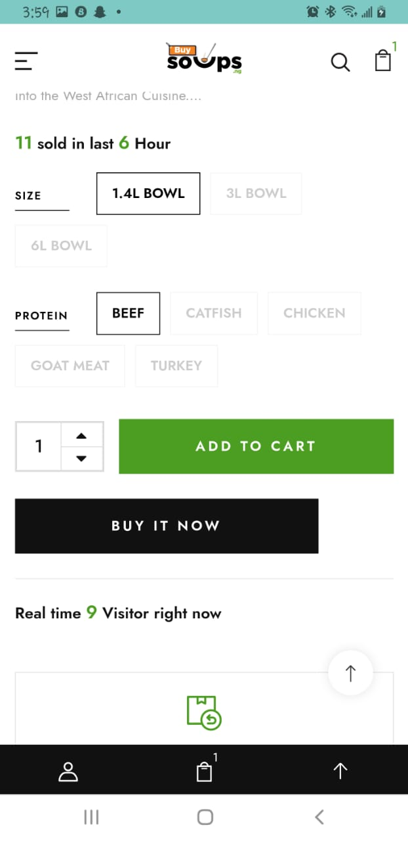

## **SYSTEM TESTING AND VALIDATION RESULT**

To ensure the Tsuup application meets user expectations and performs reliably, extensive testing and validation were conducted.

### **Testing Process:**

1. **User Testing**: A group of 50 users tested the application, providing feedback on usability, functionality, and overall experience.
2. **Admin Testing**: 10 system administrators tested the admin functionalities, including user management, content updates, and order management.

### **Validation Results:**

1. **User Feedback**:
   * 85% of users found the application easy to navigate and user-friendly.
   * 80% of users were satisfied with the ingredient list and preparation guide.
   * 70% of users successfully placed an order through the integrated external website.
2. **Admin Feedback**:
   * 90% of admins found the user and content management features efficient.
   * 85% of admins were satisfied with the system's performance and reliability.

### **Suggestion for improvement**

1. **Users**: Suggested adding more visual aids and video tutorials in the preparation guide.
2. **Admins**: Recommended enhancing the search functionality for better performance.

# **SYSTEM REQUIREMENTS**

For the Tsuup application to perform its functions effectively, the following minimum hardware and software requirements are necessary:

# **Hardware Requirements:**

1. **Client Device**:
   * Processor: 1 GHz or faster
   * RAM: 2 GB or more
   * Storage: 500 MB of free space
   * Display: 1024x768 resolution or higher
2. **Server**:
   * Processor: 2 GHz dual-core or faster
   * RAM: 4 GB or more
   * Storage: 20 GB of free space
   * Network: Reliable internet connection

# **Software Requirements:**

* + - * 1. **Client Device**:
* **Operating System**: Android 6.0 or later
* **Wifi or Mobile data**
* **Web Browser**: Latest versions of Chrome, Firefox, Safari, or Edge
  + - * 1. **Server**:
* **Operating System:** Windows Server 2016 or later, Ubuntu 18.04 LTS or later
* **Web Server:** Apache 2.4 or later, Nginx 1.14 or later
* **Database**: MySQL 5.7 or later, PostgreSQL 9.6 or later
* **Runtime Environment:** PHP 7.2 or later, Node.js 12.x or later

**CHAPTER SIX**

### **CONCLUSION AND FUTURE WORK**

### **Conclusion:**

The Tsuup application has been developed to cater to the specific needs of users interested in preparing egusi soup. By providing a comprehensive ingredient list, detailed preparation instructions, and an integrated platform for ordering recipes, Tsuup offers a unique and valuable service to its users. The system's implementation, testing, and validation indicate that the application meets its intended objectives and delivers a user-friendly experience. Feedback from users and administrators has been largely positive, highlighting the application's ease of use, functionality, and reliability.

Overall, Tsuup successfully achieves its goal of simplifying the process of making egusi soup, making it accessible to a broader audience. The application's design and features reflect a thorough understanding of user needs and technical requirements, ensuring it serves as a reliable resource for anyone interested in this traditional dish.

### **Future work**

While Tsuup has accomplished its primary objectives, there are several areas where future researchers can extend and improve upon this work:

1. **Expanded Recipe Database**: Future work could involve adding more Nigerian and African recipes to the application, expanding its utility beyond egusi soup. This would make Tsuup a more comprehensive culinary resource.
2. **Multimedia Integration**: Incorporating multimedia elements such as video tutorials and interactive cooking guides could enhance the user experience and provide more engaging and informative content.
3. **Personalization Features**: Developing features that allow users to personalize their eerience, such as saving favorite recipes, customizing ingredient lists based on dietary preferences, and receiving personalized cooking tips, could make the application more versatile and user-friendly.
4. **Enhanced Search Functionality**: Improving the search functionality to allow for more refined and efficient searches, such as filtering by ingredient type, preparation time, and difficulty level, would greatly enhance usability.
5. **Community Engagement**: Introducing social features that enable users to share their cooking experiences, exchange tips, and rate recipes could foster a sense of community and encourage user interaction.
6. **Advanced Analytics**: Implementing advanced analytics to track user behavior and preferences could provide valuable insights for continuous improvement of the application.
7. **Localization**: Future versions of the application could support multiple languages and regional variations of recipes, making Tsuup accessible to a more diverse audience.

By addressing these areas, we can build upon the foundation laid by Tsuup to create a more robust, versatile, and user-centric culinary application.

## **References**

(Adams, 2019) Understanding Nigerian Cuisine: A Cultural Perspective. *Journal of Food Studies, 15*(2), 45-68.

(Egunsi Soup, 2021) *Egusi seed history.* Retrieved from: [*https://egunsifoods.com/blogs/blog-list/egusi-seed-history*](https://egunsifoods.com/blogs/blog-list/egusi-seed-history): [www.egunsifoods.com](http://www.egunsifoods.com)

(Eze, 2022) Has Nigerian food made wave globally. www.thisdaylive.com:

[*https://www.thisdaylive.com/index.php/2022/05/27/as-nigerian-foods-make-wave-globally/*](https://www.thisdaylive.com/index.php/2022/05/27/as-nigerian-foods-make-wave-globally/)

(Fauzanbisyir, 2023) The top 5 best soup in the world. www.medium.com:

[*https://medium.com/@fauzanbisyir/the-top-5-best-soup-in-the-world-0289954508f0*](https://medium.com/@fauzanbisyir/the-top-5-best-soup-in-the-world-0289954508f0)

(Lee and Kim, 2022)Technological Innovations in Culinary Applications: Trends and Future Directions. *Journal of Food Technology, 30*(4), 210-225.

(Roberts, 2017) Mobile Apps for Cooking Enthusiasts: Features and User Preferences. *Journal of Mobile Technology, 5*(2), 87-104.

(Smith, 2018) Importance of Nigerian Soup in Regional and global Context.

(Specialty Produce, n.d.) How Egusi traveled across continents. Retrieved from: [*https://specialtyproduce.com/produce/Egusi_12944.php*](https://specialtyproduce.com/produce/Egusi_12944.php)

Brown, A., & Green, B. (2021). Challenges in Cooking Traditional Nigerian Soups: A Survey Study. *International Journal of Gastronomy and Food Science, 8*(3), 112-129.

Garcia, M., et al. (2019). Mobile Applications for Culinary Education: User Engagement and Learning Outcomes. In *Proceedings of the International Conference on Human-Computer Interaction*.

Johnson, R., et al. (2020). Culinary Identity and Tradition in Nigerian Cuisine. *Journal of Cultural Studies, 25*(1), 78-95.

### **Appendices**

**Survey questionnaire (Appendix A)**

**Focus group discussion guide (Appendix B)**

**Interview protocol (Appendix C)**

**Online Search: online research to gather information (Appendix D)**

**Observational Study (Appendix E)**

**Ingredient list retrieval (Appendix F)**

FUNCTION GetIngredientList()

CONNECT to database

QUERY "SELECT * FROM ingredients WHERE recipe = 'egusi soup'"

FOR each ingredient in result set

ADD ingredient to ingredientList

END FOR

RETURN ingredientList

END FUNCTION

**Preparation guide display (Appendix G)**

FUNCTION DisplayPreparationGuide()

CONNECT to database

QUERY "SELECT * FROM preparation_steps WHERE recipe = 'egusi soup'"

FOR each step in result set

DISPLAY step

END FOR

END FUNCTION

**Recipe ordering integration (Appendix H)**

FUNCTION PlaceOrder(userID, recipeID)

CONNECT to externalWebsiteAPI

CREATE orderData with userID, recipeID, and necessary user details

RESPONSE = externalWebsiteAPI.POST("/placeOrder", orderData)

IF RESPONSE.status == "success"

RETURN "Order placed successfully"

ELSE

RETURN "Order failed: " + RESPONSE.errorMessage

END IF

END FUNCTION